Report

# Name: Pavan Tiwari

Course: AI and ML

Face Feature Extraction

# Problem Statement: Face Feature Extraction Using PCA.

**Prerequisites**

What things you need to install the software and how to install them:

Python 3.6 This setup requires that your machine has latest version of python. The following url <https://www.python.org/downloads/>can be referred to download python. Once you have python downloaded and installed, you will need to setup PATH variables (if you want to run python program directly, detail instructions are below in how to run software section). To do that check this: [https://www.pythoncentral.io/add-python-to-path-python-is-not- recognized-as-an-internal-or-external-](https://www.pythoncentral.io/add-python-to-path-python-is-not-recognized-as-an-internal-or-external-command/) [command/](https://www.pythoncentral.io/add-python-to-path-python-is-not-recognized-as-an-internal-or-external-command/). Setting up PATH variable is optional as you can also run program without it and more instruction are given below on this topic.

Second and easier option is to download anaconda and use its anaconda prompt to run the commands. To install anaconda check this url <https://www.anaconda.com/download/>You will also need to download and install below 3 packages after you install either python or anaconda from the steps above Sklearn (scikit-learn) numpy scipy if you have chosen to install python 3.6 then run below commands in command prompt/terminal to install these packages pip install -U scikit-learn pip install numpy pip install scipy if you have chosen to install anaconda then run below commands in anaconda prompt to install these packages conda install -c scikit-learn conda install -c anaconda numpy conda install -c anaconda scipy

# **Dataset used**

The data source used for this project is been generated using sklearn library it’s the famous dataset which consist of famous personality images.

# **Method used for detection**

PCA

# Importing the libraries and capturing images:

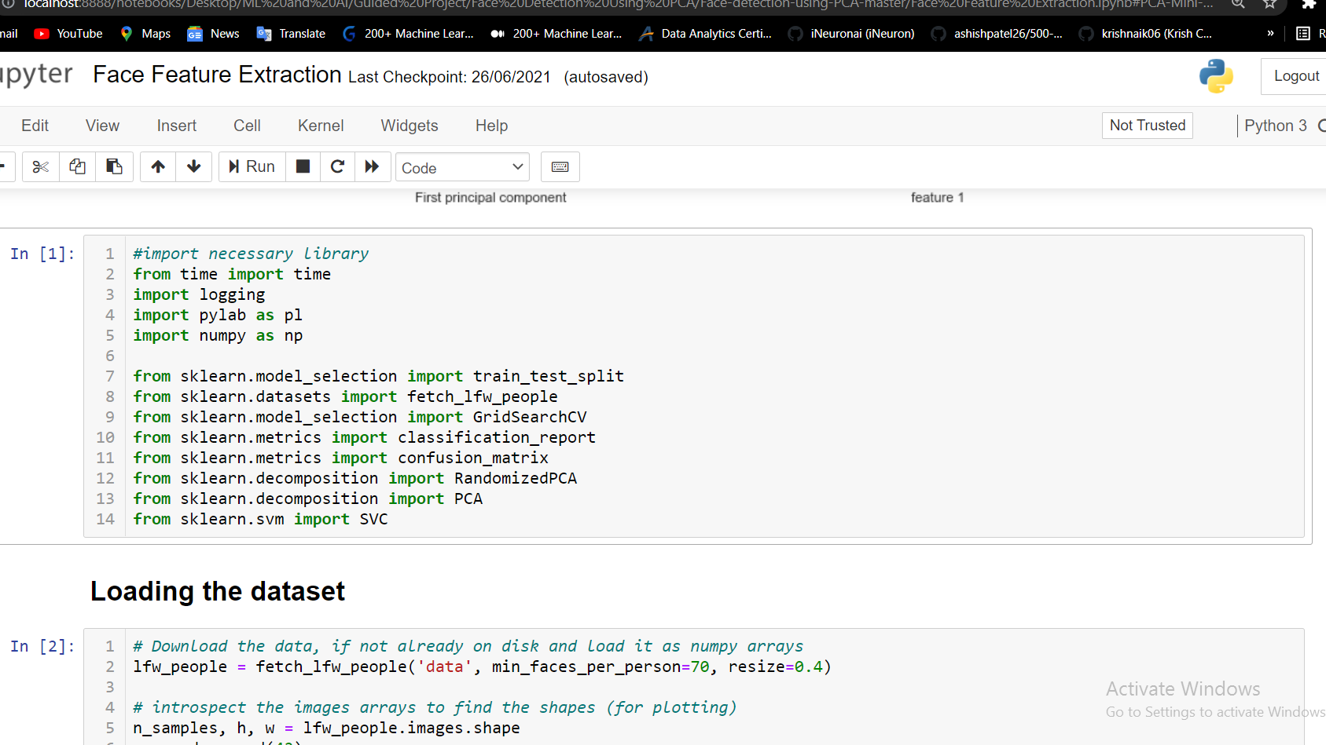

1. Splitting data for traning and Computing PCA:

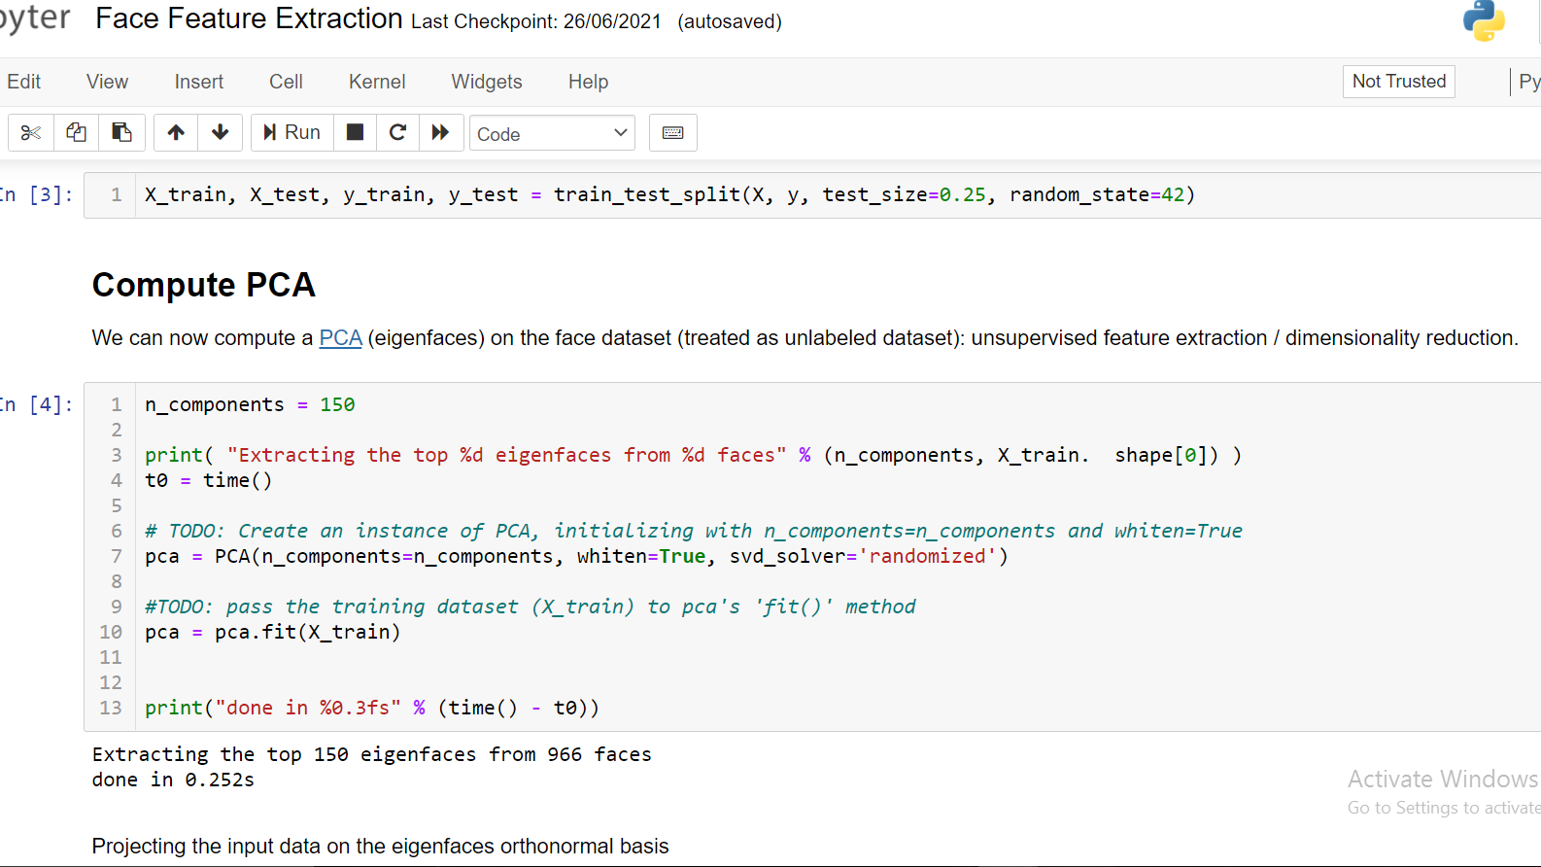

1. Training the Model:

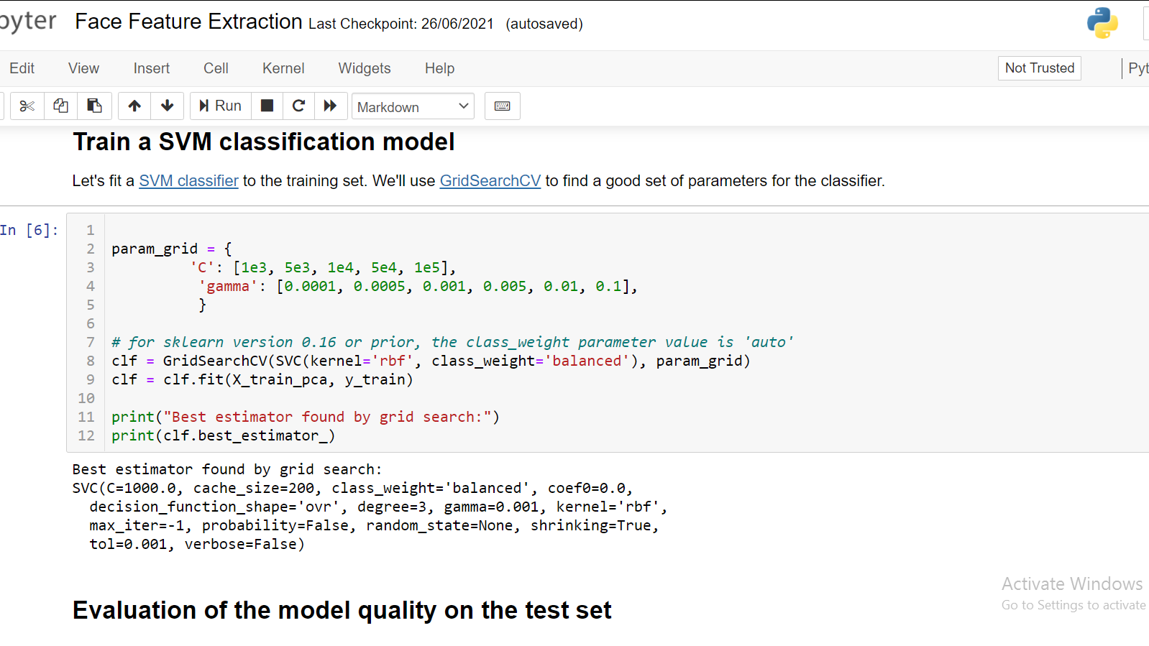

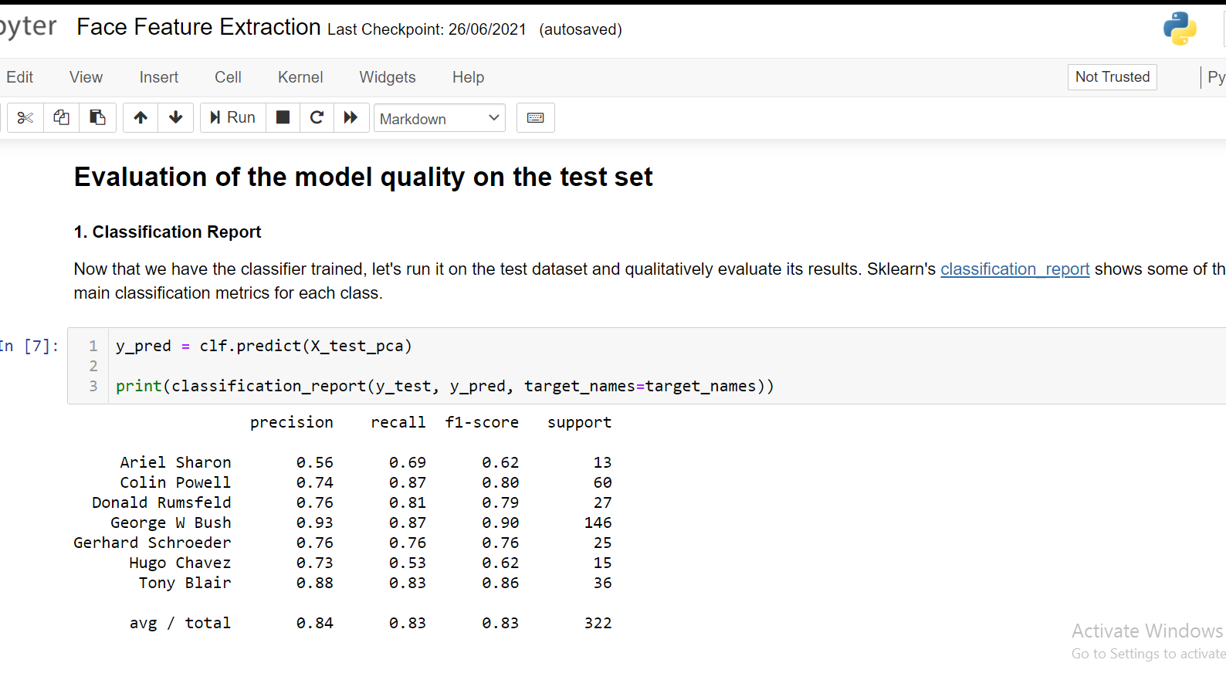

1. **Plotting the most significant Eigen Faces.**

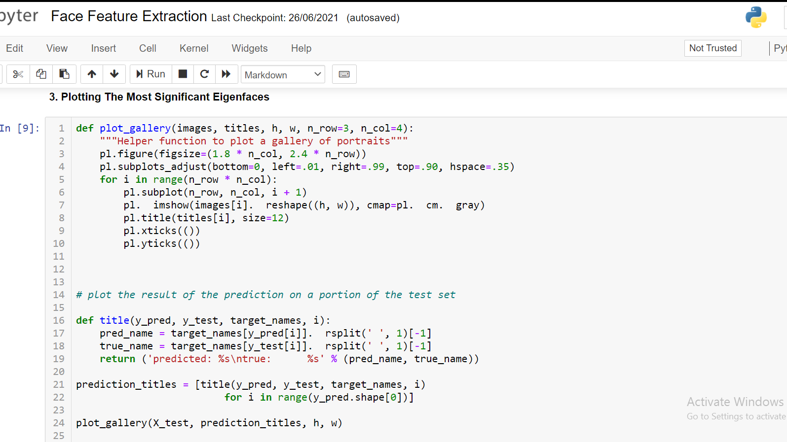

# FINAL OUTPUT

